Introduction
File transfer is a common operation in computer networks, but the security of the protocol used greatly affects the confidentiality and integrity of the transmitted data. This project was carried out to practically demonstrate the security weaknesses of File Transfer Protocol (FTP) and to compare it with Secure File Transfer Protocol (SFTP), which uses encryption.

By configuring both FTP and SFTP environments and analyzing captured network traffic using Wireshark, I was able to visually observe how data is exposed in FTP and protected in SFTP. This experiment reinforces the importance of using secure communication protocols in real-world network environments.

Aim:
To practically demonstrate the security risks of FTP and compare them with SFTP.
Objectives:
- Configure FTP and SFTP environments
- Capture and analyze network traffic
- Observe plaintext vs encrypted communication
- Reinforce the importance of secure protocols

Methodology
Virtual lab environment created
FTP and SFTP services configured
Files transferred between client and server
Network traffic captured using Wireshark
Results analyzed and compared

Background of FTP and SFTP
FTP:
Traditional file transfer protocol
Transmits data in plaintext
SFTP:
Secure file transfer protocol
Operates over encrypted SSH tunnel

Tools Used
- Kali Linux (Server)
- Windows (Client)
- FileZilla Client
- Wireshark
- OpenSSH
- FTP Server (vsftpd)

Environment and Network Setup
- FTP server installed and configured
- User account created
- Service verified as running created a controlled virtual lab environment using Kali Linux as the server system and Windows as the client system, both running on virtual machines. The machines were configured on the same network to allow proper communication.
- confirmed network connectivity by checking the assigned IP addresses and ensuring the network interface was active. This IP address was later used when establishing both FTP and SFTP connections from the client to the server.
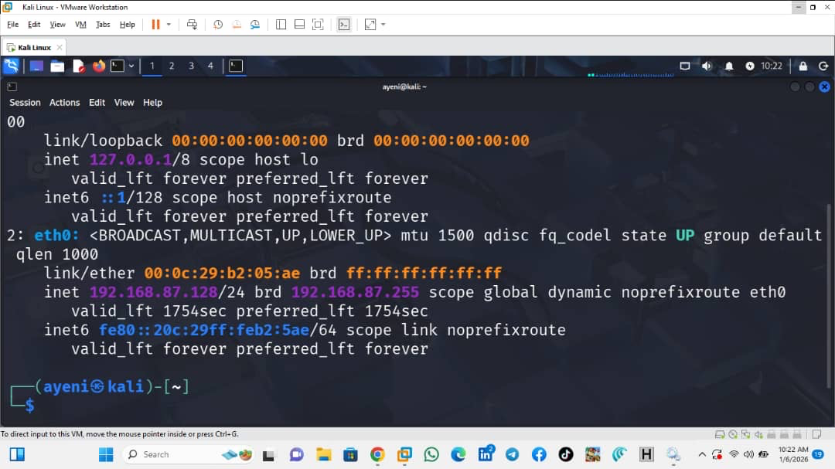

FTP Server and Client Configuration
- FTP connection established
- Username and password entered
- Sample file transferred

To demonstrate unsecured file transfer, installed and configured the vsftpd FTP server on the Kali Linux system. A local FTP user account was created and assigned appropriate permissions for file transfer. After configuration, then started the FTP service and verified that it was running correctly.

On the Windows client system, used FileZilla Client to connect to the FTP server using the server’s IP address, FTP username, and password. Once connected, transferred a sample file from the client to the server to generate FTP traffic for analysis.

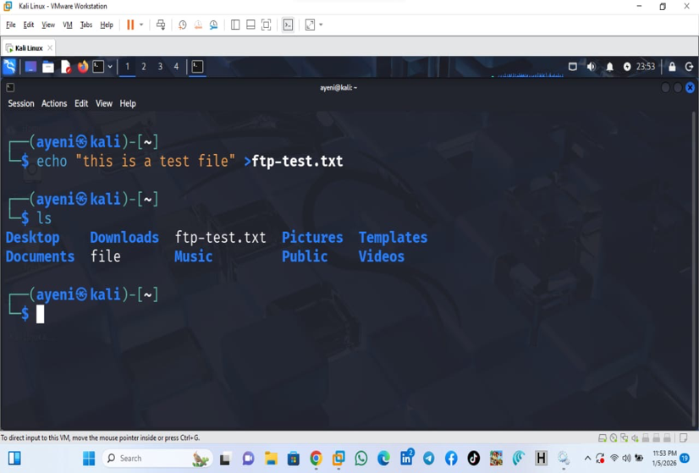
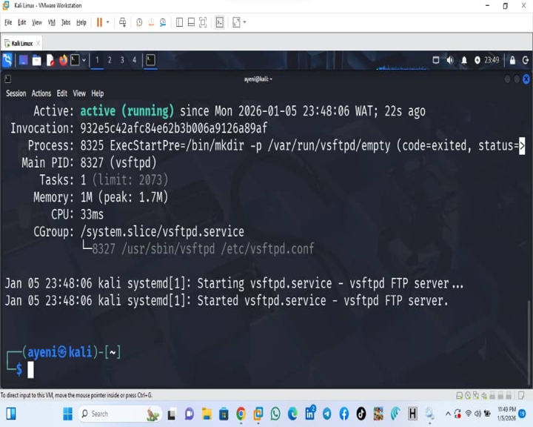
(Screenshot attached: FTP server running and FileZilla FTP connection)

Capturing and Analyzing FTP Traffic
Traffic captured using Wireshark
USER and PASS commands identified
Credentials visible in plaintext
opened Wireshark on the Kali Linux system and selected the correct network interface used by the virtual machine. While performing the FTP file transfer, captured the network traffic in real time.

Upon inspecting the captured packets, observed FTP commands such as USER and PASS being transmitted in plaintext. Both the username and password were clearly readable within the packet data. In addition, file transfer commands and data streams were visible, confirming that FTP does not encrypt transmitted information.

This analysis clearly demonstrated that FTP is vulnerable to packet sniffing attacks, allowing attackers to intercept sensitive credentials and file contents.

(Screenshots attached: FTP USER command, PASS command, plaintext data)
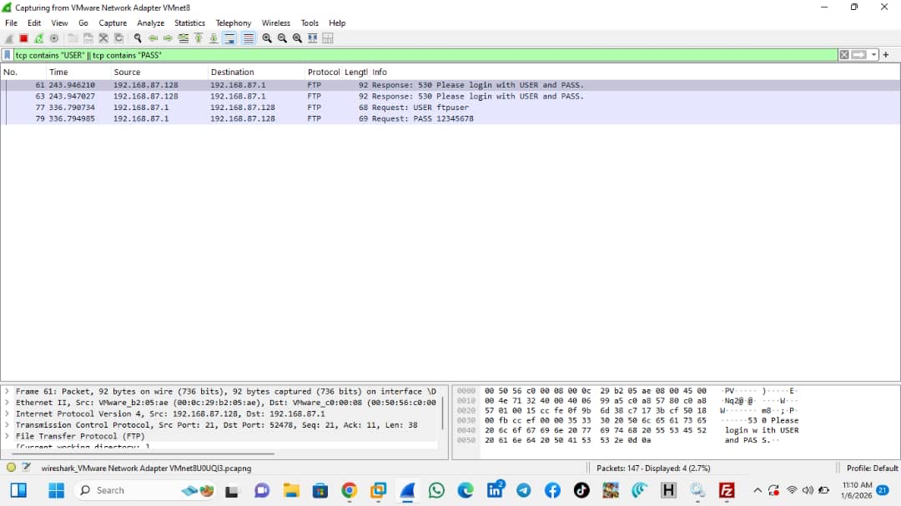
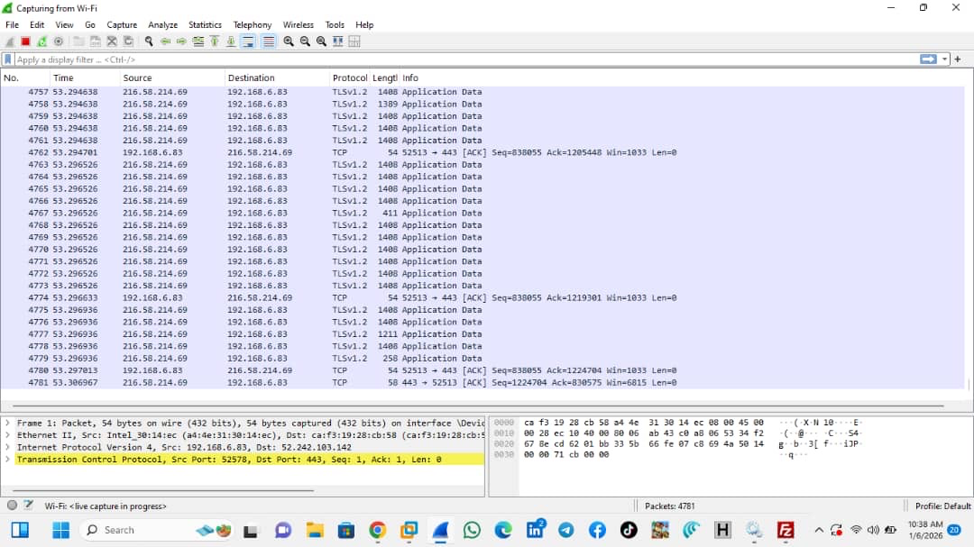
SFTP Server Configuration and Secure File Transfer
SSH service enabled
SFTP configured
Secure connection established

To demonstrate a secure alternative, enabled the SSH service on the Kali Linux system, which provides the foundation for SFTP. Using the same client system, configured FileZilla to connect via SFTP (SSH File Transfer Protocol).
authenticated using the same server credentials and transferred the same sample file. A new Wireshark capture session was started to ensure only SFTP traffic was analyzed.

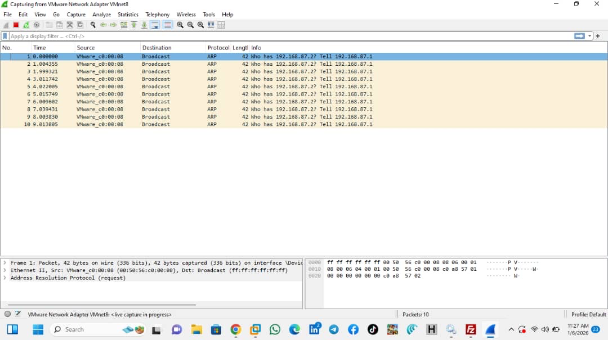
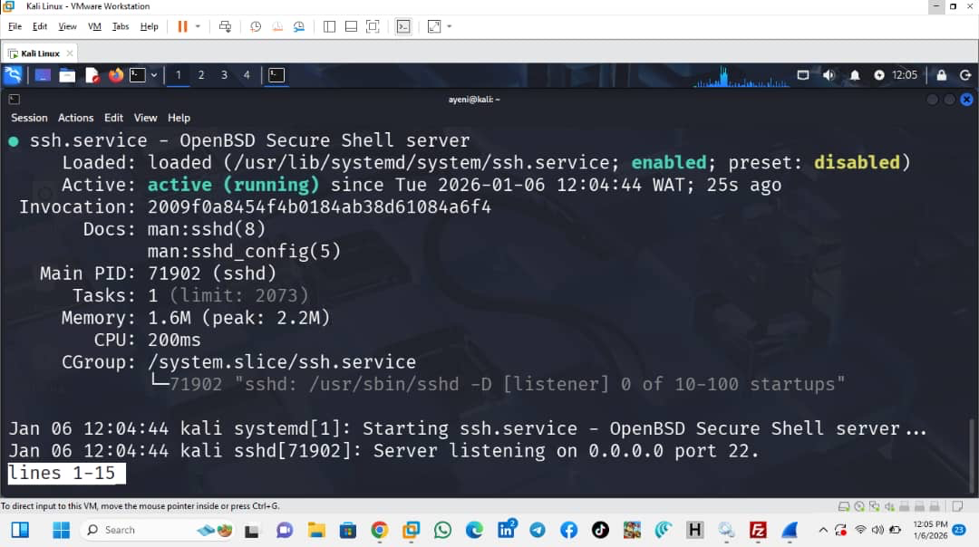
(Screenshot attached: SFTP connection setup)

Capturing and Analyzing SFTP Traffic

Traffic captured during SFTP transfer

Data observed as encrypted SSH packets

No readable credentials or content

During the SFTP file transfer, I analyzed the captured packets in Wireshark. Unlike FTP, all observed traffic appeared as encrypted SSH packets. No readable usernames, passwords, or file contents were visible in the packet data.

This confirmed that SFTP protects both authentication credentials and file data by encrypting the entire communication session, preventing unauthorized access or modification.

(Screenshot attached: Encrypted SSH/SFTP packets)
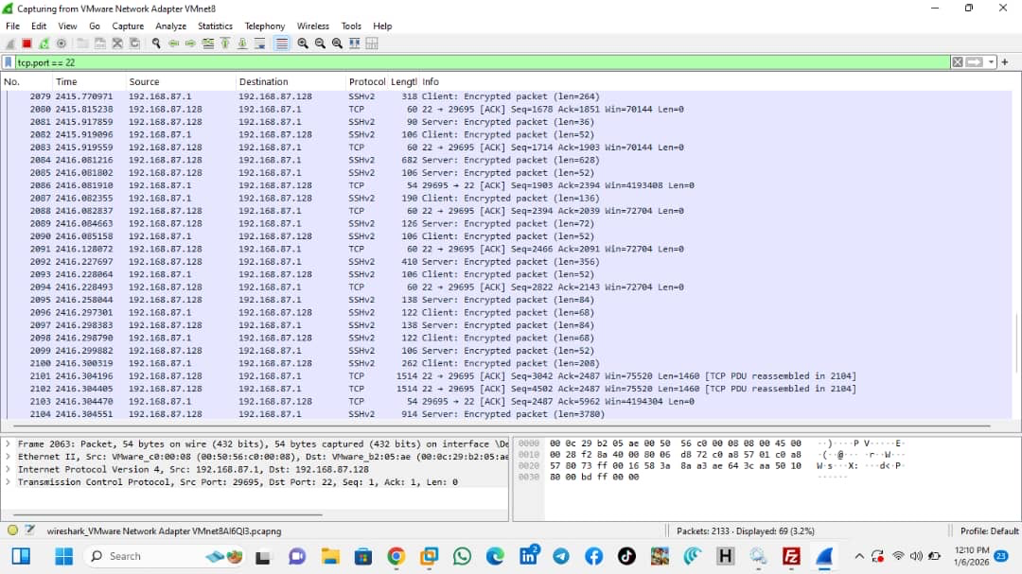

During the FTP session, Wireshark captured the username and password in plaintext, demonstrating that FTP does not encrypt credentials. In contrast, when using SFTP over SSH, the captured traffic was encrypted and no readable credentials or file contents were visible, proving that SFTP provides confidentiality and security.

Comparative Analysis: FTP vs SFTP

From the experiment, FTP was shown to be insecure due to its lack of encryption. Credentials and data sent over FTP can easily be intercepted by attackers using packet sniffing tools such as Wireshark.

In contrast, SFTP provides strong security by operating over an encrypted SSH tunnel. This ensures confidentiality, integrity, and authentication, making SFTP suitable for real-world applications such as corporate networks, cloud file transfers, and remote system administration.

Real World Implications
In real-world environments, the use of unsecured FTP can lead to serious security breaches, including credential theft, data leakage, and unauthorized system access. This is why modern systems and organizations strongly recommend or enforce the use of SFTP or other encrypted protocols.

The experiment highlights the practical importance of encryption in protecting data during transmission and explains why secure protocols are preferred in modern network security practices.

Conclusion
This project successfully demonstrated the security differences between FTP and SFTP through practical setup and packet analysis. By observing real network traffic, I confirmed that FTP exposes sensitive data, while SFTP effectively protects it through encryption. Overall, this experiment emphasized the importance of secure communication protocols and provided hands-on experience in network traffic analysis and cybersecurity fundamentals.

